Bash Scripting
Script: a text file that contains a sequence of commands for linux based operating system.

Nano myscript.sh :
ls -l
To run: ./myscript.sh
** no executable permission when a file is created
chmod u+x myscript.sh
./myscript.sh

#! : shebang / hashbang determines which shell to use
e.g.
#! /bin/bash

using Variables and Comments
# : comment

to define variables use $:

echo $BASH : system variable. Returns direcory of bash
echo $BASH_VERSION : Returns the verison of bash
echo $HOME : returns directory of home folder
echo $PWD : returns present working directory

user defined variables:
name = Mark
echo the name is $name

** variable name can’t start with a number

Read User Input
echo "Enter name : "
read name1 name2 name3
echo "Entered name1 : $name1"
echo "Entered name2 : $name2"
echo "Entered name3 : $name3"

** to take input at the same line :
read -p "username : " user_var
echo "username : $user_var "

** to hide input such as password:: -s
** echo extra
read -p "username : " user_var
read -sp "password : " password
echo
echo "username : $user_var "
echo "password : $password "

** allow user multiple inputs
echo "Enter names: "
read -a names
echo "Names : ${names[0]}, ${names[1]}"

** no variable name after read
** it stored as $REPLY
echo "Enter names: "
read
echo "Names : $REPLY"

Pass Arguments to a Bash-Script

echo $0 $1 $2 $3 " > echo $1 $2 $3"

args=("$@")

#echo ${args[0]} ${args[1]} ${args[2]}

# similar to echo ${args[0]} ${args[1]} ${args[2]} writing each one by one
echo $@

#returns the number of arguments passed e.g. 3
echo $#

if else statement

If [condition]
then
statement
elif [condition]
statement
else
statement
fi

** numerical comparison with angle bracket use ((
** string comparison with angle bracket use [[

String Comparisons:
---------------------------------
= compare if two strings are equal
!= compare if two strings are not equal
-n evaluate if string length is greater than zero
-z evaluate if string length is equal to zero
Examples:
[ s1 = s2 ] (true if s1 same as s2, else false)
[ s1 != s2 ] (true if s1 not same as s2, else false)
[ s1 ] (true if s1 is not empty, else false)
[ -n s1 ] (true if s1 has a length greater then 0, else false)
[ -z s2 ] (true if s2 has a length of 0, otherwise false)

Number Comparisons:
------------------------------------
-eq compare if two numbers are equal
-ge compare if one number is greater than or equal to a number
-le compare if one number is less than or equal to a number
-ne compare if two numbers are not equal
-gt compare if one number is greater than another number
-lt compare if one number is less than another number
Examples:
[ n1 -eq n2 ] (true if n1 same as n2, else false)
[ n1 -ge n2 ] (true if n1greater then or equal to n2, else false)
[ n1 -le n2 ] (true if n1 less then or equal to n2, else false)
[ n1 -ne n2 ] (true if n1 is not same as n2, else false)
[ n1 -gt n2 ] (true if n1 greater then n2, else false)
[ n1 -lt n2 ] (true if n1 less then n2, else false)

File test operators
File exist or not
regular file or block special file or character special file ??

block special file : music, video files. Includes binary data -b
character special file: normal file. Txt, data etc.. -c

** file empty or not : -s

check read, write or executable permission:
-r -w -x

How to append output to the end of text file

Append.sh

AND – OR

andor.sh
-0 or -a with single bracket
|| or && with double brackets two condition combined.
|| or && with single brackets as two condition.

Perform arithmetic operations
Arithmetic.sh

The Arithmetic expression is very important feature for performing number arithmetic operations in scripts.
By default variables are treated as strings in bash scripts.
But parsing a string to numbers is very easy using double parentheses and external command such as expr.

Arithmetic operations in Bash Shell
Arithmetic operations can be done on integers using the following methods

$(( expression ))
echo "Addition = $(( number_1 + number_2 ))"

expr — evaluate expression
we can also use expr command to perform Arithmetic operations on numbers.

echo "Addition = $(expr $number_1 + $number_2 )"

Floating Operations

bc, for basic calculator (often referred to as bench calculator), is "an arbitrary-precision calculator language" with syntax similar to the C programming language. bc is typically used as either a mathematical scripting language or as an interactive mathematical shell.

bc [ -hlwsqv ] [long-options] [ file ... ]

bc is a language that supports arbitrary precision numbers with interactive execution of statements. There are some similarities in the syntax to the C programming language. A standard math library is available by command line option. If requested, the math library is defined before processing any files. bc starts by processing code from all the files listed on the command line in the order listed. After all files have been processed, bc reads from the standard input. All code is executed as it is read. (If a file contains a command to halt the processor, bc will never read from the standard input.)

-l : math package

case statement

The case statement is used to execute statements based on specific values. Often used in place of an if statement, if there are a large number of conditions. The variable is compared with the values using the shell wildcards ( ? * […] ) , NOT regular expressions. All the statements are executed for the first matching value until the ending ;;. If no value matches, then the default *) case is executed, if present.
case statement:
Specify number of possible values for variable
Statement block executed for matching value
Only one block executed

case experssion in
pattern1 )
statements ;;
pattern2 )
statements ;;
…..
esac

Array variables

os=(‘ubuntu’ ’windows’ ‘kali’)

** zero indexing

echo “${os[@]}” – to all
echo “${os[1]}” – to all
echo “${os[2]}” – to all

**! : prints indexes
** # : length of array

**ADD ELEMENTS
os[index of new adde element] = “mac”

## remove element
unset os[2]

While Loop

While [condition]
do
command1
command2
command3
done

(( n++ )) : increment

SLEEP
Sleep command gives a pause of input seconds for each iter

Read a File Content While Loop
Readfile.sh

UNTIL Loop

Until [condition]
do
command1
command2
command3
done

** if condition is false then commands are executed.

Until.sh

FOR Loop

FOR
do
command1
command2
command3
done

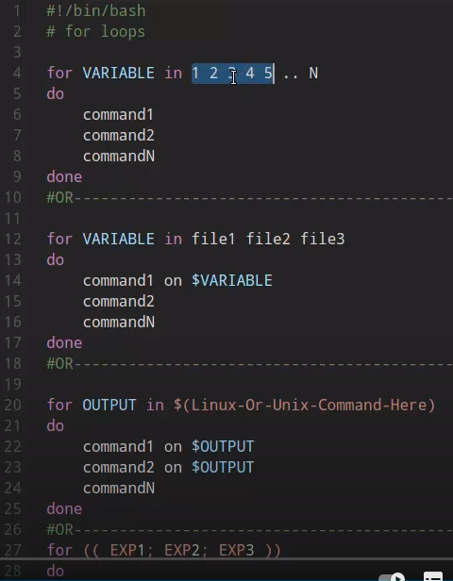

SELECT Loop
Easy menu
SELECT COMMAND Constructs simple menu from word list. It Allows user to enter a number instead of a word. So User enters sequence number corresponding to the word.

Select name in list
do
command1
command2
..
..
CommandN
done

select.sh

BREAK and Continue
The break statement is used to exit the current loop before its normal ending. The continue statement resumes iteration of an enclosing for, while, until or select loop.

Functions

Function name() {
commands
}

name() {
commands
}

funct.sh

Local Variables
Variables defined within functions are global, i.e. their values are known throughout the entire shell program keyword “local” inside a function definition makes referenced variables “local” to that function. Local variables can be created by using the keyword local.

Readonly Command
readonly command can be used to to make you variables and functions read only that means you cannot change the value of variables or you can not overwrite a function.

DEBUG
-x option
sh -x script [arg1 ...]
bash -x script [arg1 ...]
These give you a trace of what is being executed.
Using the set Bash built-in you can run in normal mode those portions of the script of which you are sure they are without fault, and display debugging information only for troublesome zones. Say we are not sure what the w command will do in the example commented-script1.sh, then we could enclose it in the script like this:

set -x # activate debugging from here
set +x # stop debugging from here

Signals and Traps
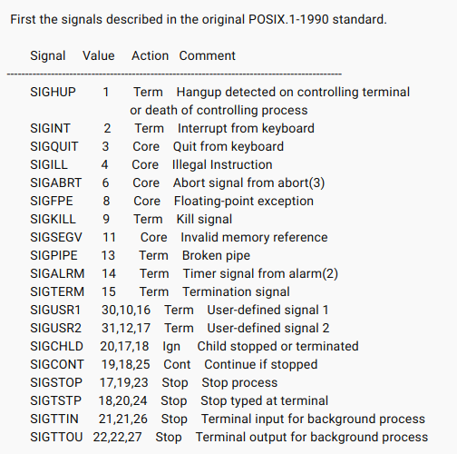

CTRL + C : SIGINT
CTRL + Z : SIGTSTP (Suspend signal)

man 7 signal

use another terminal and type : kill -9 pid

